EXPERIMENT 10: INTRODUCTION TO ANTIVIRUS

AIM

To understand how antivirus software works and the techniques used to detect malware.

PROCEDURE

- Study antivirus concepts and features.
- Learn detection methods like signature-based (static) detection.
- Explore advanced techniques such as behavioral analysis.
- Perform basic testing of antivirus detection mechanisms.

QUESTIONS

TASK 1 - Antivirus Software

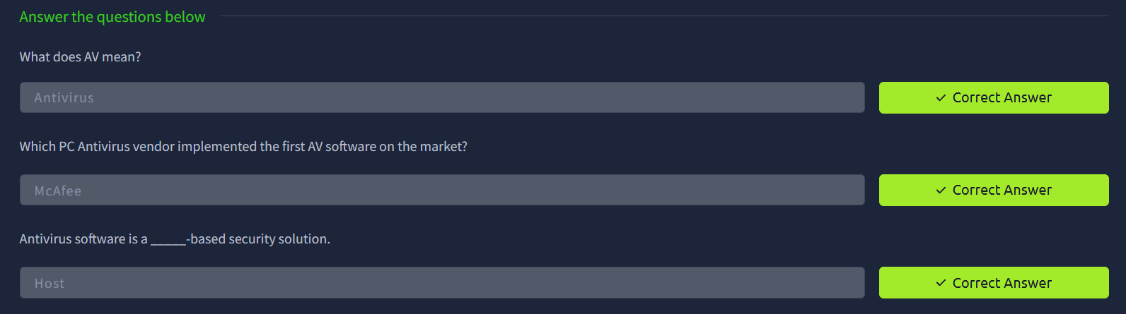

TASK 2 - Antivirus Features

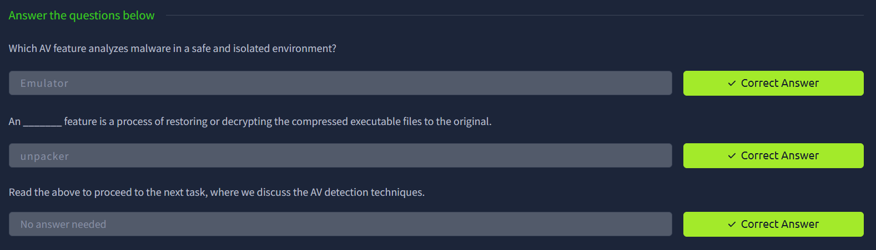

TASK 3 - AV Static Detection

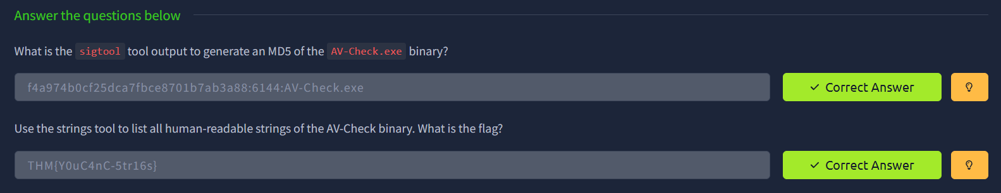

TASK 4 - Other Detection Techniques

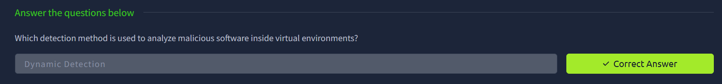

RESULT

Understood how antivirus systems detect and prevent malware using different detection techniques.

